**A PRELIMINARY REPORT ON**

**“Placement Management System”**

SUBMITTED TO THE EDUBRIDGE INDIA PRIVATE LIMITED

**SUBMITTED BY**

**Ragavi S Batch No: EON-5755**

**Under The Guidance of**

Amruta Deore

**DEPARTMENT OF S PRAYAS CERTIFIED JAVA FULL STACK DEVELOPER 02**

**THANE**

**EDUBRIDGE INDIA PRIVATE LIMITED**

**2021-2022.**

**ACKNOWLEDGEMENT**

It gives all of us great pleasure in presenting the preliminary project report on “Placement Management System”. With due respect and gratitude we would like to take this opportunity to thank the internal guide of our project Mrs.Amruta Deore for giving us all the help and guidance we needed. We are really grateful for this kind support. She has always encouraged us and given us the motivation to move ahead. She has put in a lot of time and effort in this project along with us and given us a lot of confidence. Also we wish to thank all the other people who have helped us in the successful completion of this project.

**Miss.Ragavi S**

# **ABSTRACT**

Placement management will provide an opportunity for students and graduates to learn new skills. They are trained on programming skills like Java, C, C++, python etc., front-end technologies, JDBC, Spring, MySQL, hibernate etc., so that they meet the requirements of industries and are eligible for the hiring process.

**Chapter 1**

**INTRODUCTION**

# **1.1 INTRODUCTION**

The objective of Placement management is to allow the students and graduates to register online for the course they wanted to learn. It also facilitates placement guidance to get placed in a company.

# **1.2 System Requirements**

## **1.2.1 Software Requirements**

1. Operating System - Windows 10.
2. Platform – Eclipse, MySQL,Servlet.

3.Language – HTML, CSS, Java, SQL.

# **1.3 MODULE**

## **1.3.1 S Login**

Login module will help in authentication of user accounts .Users who have valid login id and password can only login into their respective accounts.

**login.html :**

<!DOCTYPE html>

<html lang="en">

<head>

<meta charset="UTF-8">

<meta http-equiv="X-UA-Compatible" content="IE=edge">

<meta name="viewport" content="width=device-width, initial-scale=1.0">

<title>Document</title>

<style>

body{

background-image: url("https://www.climbsolutionsinfo.com/wp-content/uploads/2016/02/full-placement-background.png");

text-align: center;

}

.primary{

border: none;

background-color: blue;

color: white;

width: 80px;

height: 40px;

cursor: pointer;

}

</style>

</head>

<body>

<div class="container " style="overflow: auto">

<h1 style="color:white; font-size: 45px; ">Login Form</h1>

<form action="LoginServlet" method="post">

<div class="form-group" name="userName">

<label for="uname" style="color:white; font-size: 25px;">User Name:</label>

<input type="text" class="form-control" id="username" placeholder="User name"name="userName" required>

</div><br>

<div class="form-group" name="userPass">

<label for="uname"style="color:white; font-size: 25px;">Password:</label>

<input type="password"class="form-control" id="password" placeholder="Password"name="userPassword" required>

</div><br>

<input type="submit" value="Login"/><br><br>

<a href="website.html">Click here to go back to the web site</a>

</form>

</div>

</body>

</html>

**1.3.2 Registration**

This module will help the user get registered from anywhere if the internet is present .This module will really simplify the task of on paper registration..

**Student Course Registration :**

<!DOCTYPE html>

<html lang="en">

<head>

<meta charset="UTF-8">

<meta http-equiv="X-UA-Compatible" content="IE=edge">

<meta name="viewport" content="width=device-width, initial-scale=1.0">

<title>Document</title>

<style>

body{

background-color: lightblue;

}

.form{

text-align: left;

border:none;

width: 50%;

}

.button{

border: none;

background-color: blue;

color: white;

width: 80px;

height: 40px;

cursor: pointer;

}

</style>

</head>

<body>

<fieldset class="form">

<form action="Student" method="post">

Name:<br><input type="text" name="Name"/><br><br/>

Email ID:<br><input type="text" name="Email"/><br><br/>

Mobile number:<br><input type="text" name="Mobileno"/><br><br/>

Gender:

<select name="Gender">

<option value="male">Male</option>

<option value="female">Female</option>

<option value="other">other</option>

</select><br>

State:<br><input type="text" name="State"/><br><br/>

City:<br><input type="text" name="City"/><br><br/>

Pincode:<br><input type="text" name="Pincode"/><br><br/>

Your Job Sector:<br><input type="text" name="Job"/><br><br/>

Your Prefered Course:<br><input type="text" name="Course"/><br><br/>

<input type="submit" value="Student"/>

</form>

</fieldset>

</body>

</html>

**Company Registration :**

<!DOCTYPE html>

<html>

<head>

<style>

body{

background-color: lightblue;

text-align:center;

padding:80px;

bottem:50px;

}

</style>

</head>

<body>

<form action="Register" method="post">

Name:<input type="text" name="Name"/><br/><br/>

Mobile No:<input type="text" name="Mobileno"/><br/><br/>

Email Id:<input type="text" name="Email"/><br/><br/>

Company name:

<input type="text" name="Company"/><br/><br/>

Country:

<select name="Country">

<option>India</option>

<option>Pakistan</option>

<option>other</option>

</select>

<br/><br/>

<input type="submit" value="register"/>

</form>

</body>

</html>

**1.3.3 Home Page**

<!DOCTYPE html>

<html>

<head>

<style>

* {

box-sizing: border-box;

}

body {

font-family: Arial;

padding: 10px;

background: #f1f1f1;

}

/* Header/Blog Title */

.header {

padding: 30px;

text-align: center;

background: white;

}

.header h1 {

font-size: 50px;

}

/* Style the top navigation bar */

.topnav {

overflow: hidden;

background-color: #333;

}

/* Style the topnav links */

.topnav a {

float: left;

display: block;

color: #f2f2f2;

text-align: center;

padding: 14px 16px;

text-decoration: none;

}

/* Change color on hover */

.topnav a:hover {

background-color: #ddd;

color: black;

}

/* Create two unequal columns that floats next to each other */

/* Left column */

.leftcolumn {

float: left;

width: 75%;

}

/* Right column */

.rightcolumn {

float: left;

width: 25%;

background-color: #f1f1f1;

padding-left: 20px;

}

/* Fake image */

.fakeimg {

background-color: #aaa;

width: 100%;

padding: 20px;

}

/* Add a card effect for articles */

.card {

background-color: white;

padding: 20px;

margin-top: 20px;

}

/* Clear floats after the columns */

.row:after {

content: "";

display: table;

clear: both;

}

.footer {

padding: 20px;

text-align: center;

background: #ddd;

margin-top: 20px;

}

.button2{

border: none;

background-color: blue;

color: white;

width: 80px;

height: 40px;

cursor: pointer;

}

@media screen and (max-width: 800px) {

.leftcolumn, .rightcolumn {

width: 100%;

padding: 0;

}

}

@media screen and (max-width: 400px) {

.topnav a {

float: none;

width: 100%;

}

}

</style>

</head>

<body style="background-color: plum;">

<div class="header" style="background-color: pink;">

<h1 style="background-color: palevioletred; color: white;">Student Portal</h1>

<p style="color: whites;">Placement panel</p>

</div>

<div class="topnav">

<a href="about.html">About</a>

<a href="course.html">Course registeration</a>

<a href="company.html">Company</a>

<a href="login.html" style="float:right;">Login</a>

</div>

<div class="row">

<div class="leftcolumn">

<div class="card">

<h2>Let's get you the job you deserve</h2>

<h5>Learn skills that get you a job today!</h5>

<div> <img src="https://www.pinclipart.com/picdir/middle/8-89908_clipart-free-download-careers-clipart-career-background-job.png" alt="image" height="20%" width="100%"></div>

<p>Work That Creates Impact</p>

<p>We take pride in assisting the unemployed youth understand their strengths, develop tomorrowâ€™s skills needed by the recruiters, and secure employment with them.</p>

</div>

<div class="card">

<h2>Get hire</h2>

<h5>Take the next step towards your personal and professional goal </h5>

<img src="https://www.aihr.com/wp-content/uploads/realistic-job-preview-background-and-featured-image.png" height="20%" width="100%" >

<p>Exploring Jobs with Featured Companies</p>

<button type="button"class="button2" formaction="company.html">Click here</button>

</div>

</div>

<div class="rightcolumn">

<div class="card">

<h2>About us</h2>

<img src="https://encrypted-tbn0.gstatic.com/images?q=tbn:ANd9GcTzMOX_gLyMpq3bJ2lB5i2GiQdX4-Hs8TOtKw&usqp=CAU" height="20%" width="100%" >

<p>India's best job search site - Find best Job openings for freshers and Professionals in top MNC and Companies across India, Apply for Banking Sales IT Jobs ...</p>

</div>

<div class="card" style="background-color: peachpuff;">

<h3>Courses</h3>

<div class="fakeimg"><p>Web development</p></div>

<div class="fakeimg"><p>Java fullstack developer</p></div>

<div class="fakeimg"><p>Software Engineer</p></div>

</div>

</div>

</div>

<div class="footer">

<h2>Footer</h2>

</div>

</body>

</html>

**1.3.4 Servlet Login**

package place;

import java.io.IOException;

import java.io.PrintWriter;

import java.sql.Connection;

import java.sql.DriverManager;

import java.sql.PreparedStatement;

import javax.servlet.ServletException;

import javax.servlet.annotation.WebServlet;

import javax.servlet.http.HttpServlet;

import javax.servlet.http.HttpServletRequest;

import javax.servlet.http.HttpServletResponse;

@WebServlet("/LoginServlet")

public class LoginServlet extends HttpServlet {

private static final long serialVersionUID = 1L;

protected void doPost(HttpServletRequest request, HttpServletResponse response) throws ServletException, IOException {

response.setContentType("text/html");

PrintWriter out = response.getWriter();

String n=request.getParameter("userName");

String p=request.getParameter("userPass");

try{

Class.forName("com.mysql.jdbc.Driver");

Connection con=DriverManager.getConnection(

"jdbc:mysql://localhost:3306/placement","root","root");

PreparedStatement ps=con.prepareStatement(

"insert into user values(?,?,)");

ps.setString(1,n);

ps.setString(2,p);

int i=ps.executeUpdate();

if(i>0)

out.print("You are successfully registered...");

}catch (Exception e2) {System.out.println(e2);}

out.close();

}

}

**1.3.4 Student course Servlet**

package place;

import java.io.IOException;

import java.io.PrintWriter;

import java.sql.Connection;

import java.sql.DriverManager;

import java.sql.PreparedStatement;

import javax.servlet.ServletException;

import javax.servlet.annotation.WebServlet;

import javax.servlet.http.HttpServlet;

import javax.servlet.http.HttpServletRequest;

import javax.servlet.http.HttpServletResponse;

@WebServlet("/Student")

public class Student extends HttpServlet {

private static final long serialVersionUID = 1L;

protected void doPost(HttpServletRequest request, HttpServletResponse response) throws ServletException, IOException {

response.setContentType("text/html");

PrintWriter out = response.getWriter();

String n=request.getParameter("Name");

String e=request.getParameter("Email");

String m=request.getParameter("Mobileno");

String g=request.getParameter("Gender");

String s=request.getParameter("State");

String c=request.getParameter("City");

String p=request.getParameter("Pincode");

String j=request.getParameter("Job");

String u=request.getParameter("Course");

try{

Class.forName("com.mysql.jdbc.Driver");

Connection con=DriverManager.getConnection(

"jdbc:mysql://localhost:3306/placement","root","root");

PreparedStatement ps=con.prepareStatement(

"insert into course values(?,?,?,?,?,?,?,?,?)");

ps.setString(1,n);

ps.setString(2,e);

ps.setString(3,m);

ps.setString(4,g);

ps.setString(5,s);

ps.setString(6,c);

ps.setString(7,p);

ps.setString(8,j);

ps.setString(9,u);

int i=ps.executeUpdate();

if(i>0)

out.print("You are successfully registered...");

}catch (Exception e2) {System.out.println(e2);}

out.close();

}

}

**1.3.3 Company Servlet**

package place;

import java.io.IOException;

import java.io.PrintWriter;

import java.sql.Connection;

import java.sql.DriverManager;

import java.sql.PreparedStatement;

import javax.servlet.ServletException;

import javax.servlet.annotation.WebServlet;

import javax.servlet.http.HttpServlet;

import javax.servlet.http.HttpServletRequest;

import javax.servlet.http.HttpServletResponse;

@WebServlet("/Register")

public class Register extends HttpServlet {

private static final long serialVersionUID = 1L;

protected void doPost(HttpServletRequest request, HttpServletResponse response) throws ServletException, IOException {

response.setContentType("text/html");

PrintWriter out = response.getWriter();

String n=request.getParameter("Name");

String m=request.getParameter("Mobileno");

String e=request.getParameter("Email");

String u=request.getParameter("Company");

String c=request.getParameter("Country");

try{

Class.forName("com.mysql.jdbc.Driver");

Connection con=DriverManager.getConnection(

"jdbc:mysql://localhost:3306/placement","root","root");

PreparedStatement ps=con.prepareStatement(

"insert into company values(?,?,?,?,?)");

ps.setString(1,n);

ps.setString(2,m);

ps.setString(3,e);

ps.setString(4,u);

ps.setString(5,c);

int i=ps.executeUpdate();

if(i>0)

out.print("You are successfully registered...");

}catch (Exception e2) {System.out.println(e2);}

out.close(); }}

**Chapter 2**

**PROJECT IMPLEMENTATION**

# 

# **2.1 SCREEN**

Login page

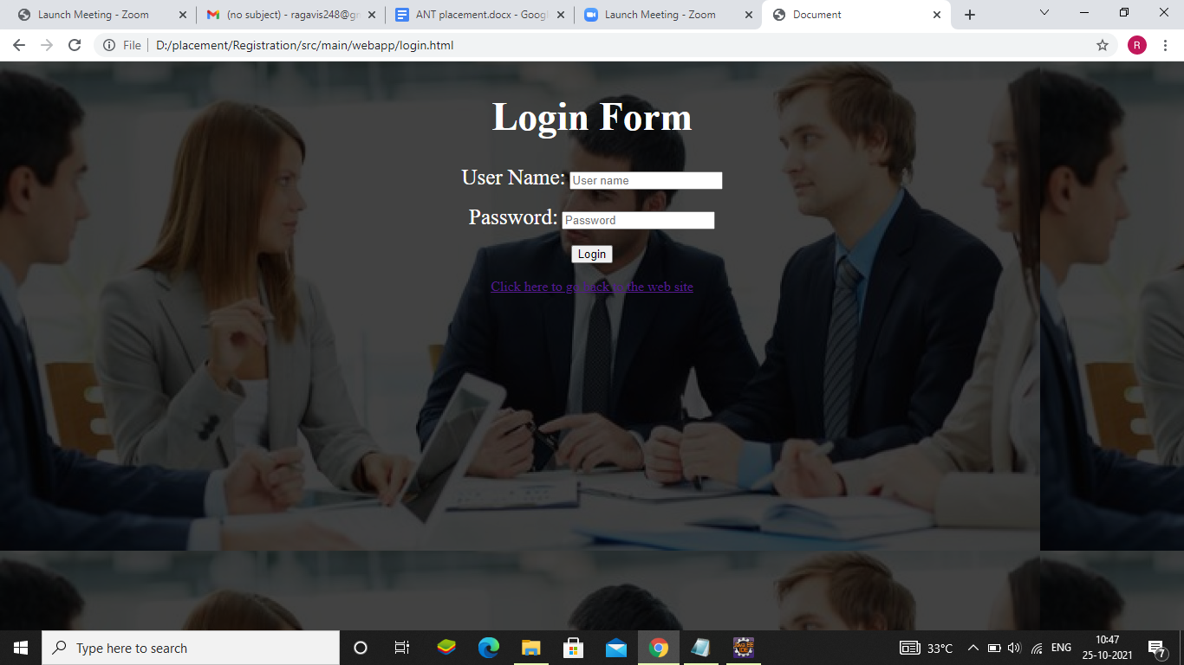

# **2.2 SCREEN**

Registration page 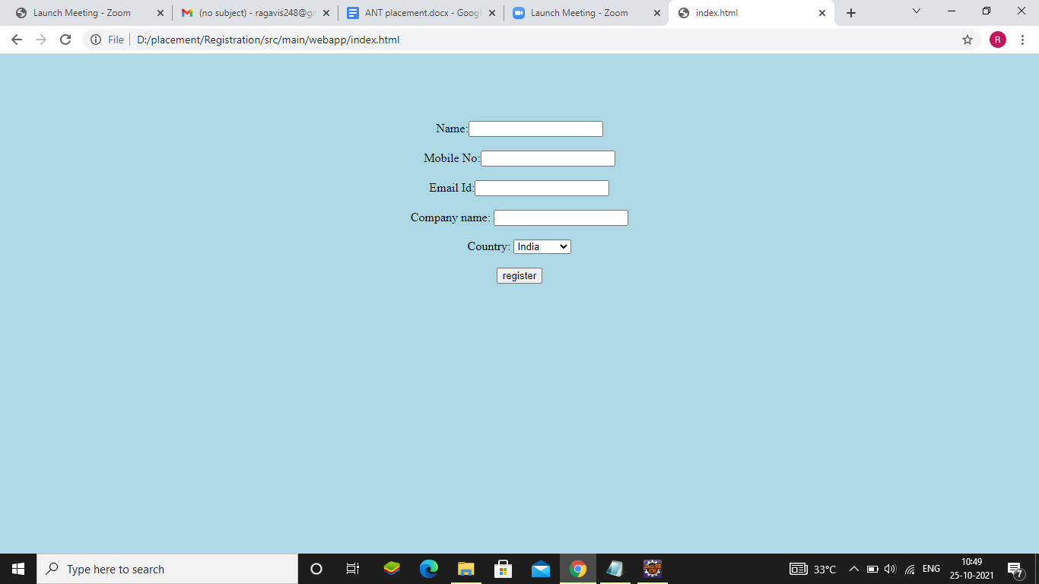

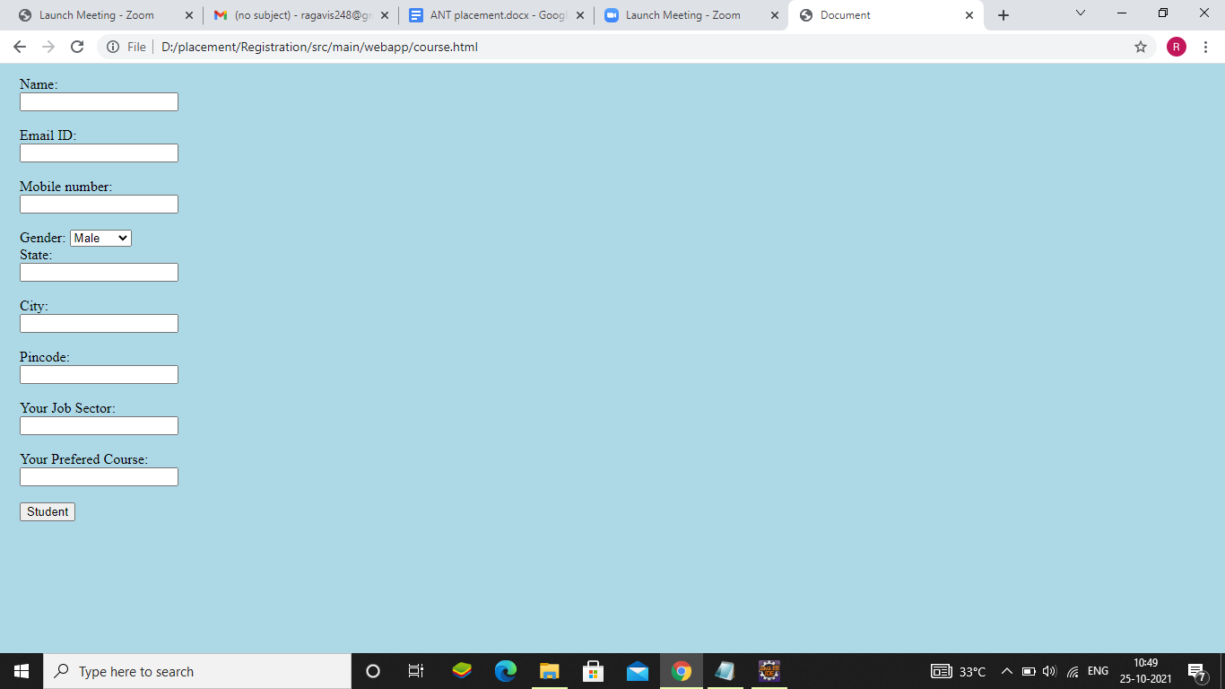

# **2.3 SCREEN**

Home page

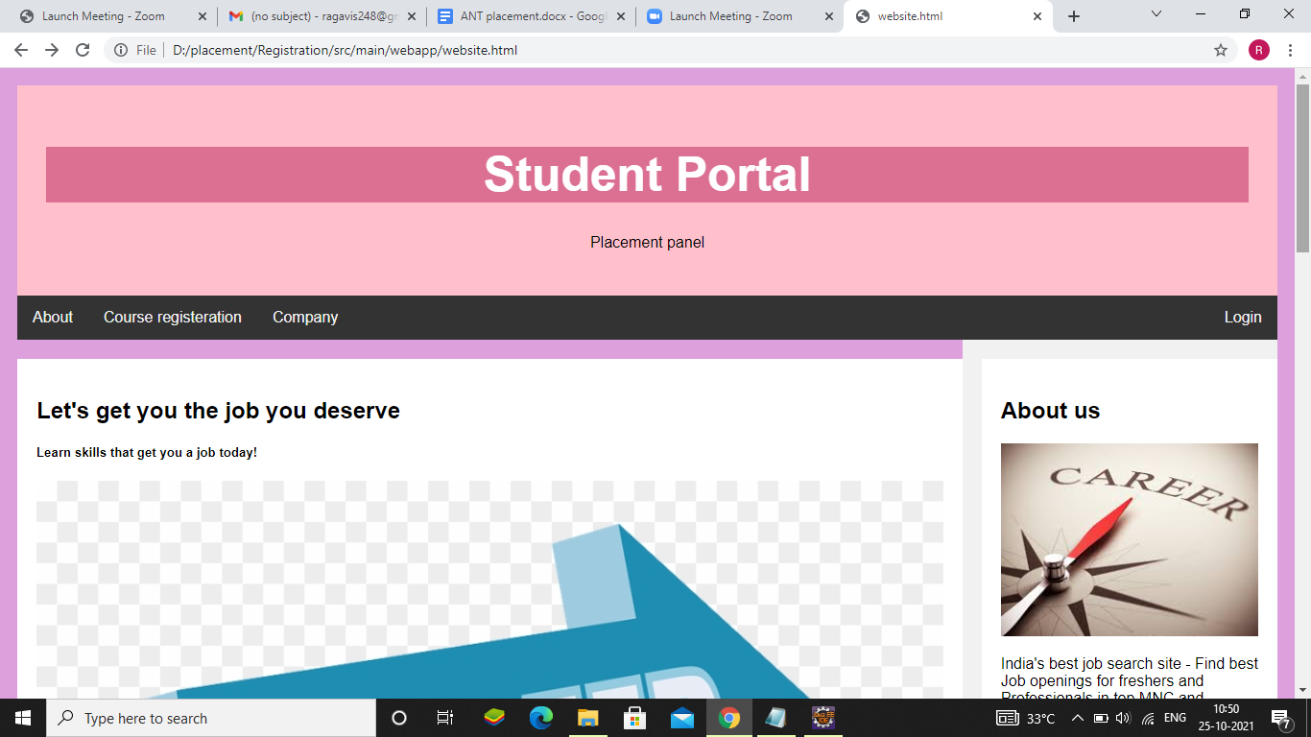

**Chapter 3**

**CONCLUSIONS**

# **3.1 CONCLUSIONS**

The Placement management System will help in providing the right job for the right person, where students and graduates can enrol their course by paying a reasonable price. The training will be a hands-on session with placement assistance.